JAVA PROGRAMMING ASSIGNMENT – 7
E-Commerce Coupon Validator
Unit 3 – Exception Handling
Topic: Custom Exceptions, throw, throws & try-catch-finally
Assessment Type: Individual Coding Assignment
Student Name | Sasanka Sekhar Kundu
Roll Number | 150096725118
Programming Language | Java
Assignment | Assignment 7 – E-Commerce Coupon Validator

1. Objective
To develop an E-Commerce Coupon Validation System in Java that accepts an order amount and coupon code, validates business rules, calculates a discount for valid coupons, and handles invalid conditions using a custom exception.

2. Problem Statement
The program must accept an order amount and coupon code, validate the coupon against its minimum order requirement, calculate the discount and final payable amount for valid coupons, and gracefully handle invalid coupons using InvalidCouponException with throw, throws, try, catch, and finally.

3. Coupon Rules
Coupon Code | Minimum Order Amount | Discount
SAVE10 | ₹1,000 | 10%
SAVE20 | ₹2,000 | 20%
SAVE30 | ₹3,000 | 30%

4. Concepts Used
- Custom Exception: InvalidCouponException extends Exception.
- throw: deliberately raises the custom exception for invalid coupon conditions.
- throws: validateCoupon() declares InvalidCouponException.
- try-catch: catches and handles the exception without crashing.
- finally: always prints the coupon-validation completion message.
- Scanner: accepts order amount and coupon code.

5. Java Source Code
import java.util.Scanner;

class InvalidCouponException extends Exception {
public InvalidCouponException(String message) {
super(message);
}
}

public class ECommerceCouponValidator {

public static double validateCoupon(String couponCode, double orderAmount)
throws InvalidCouponException {

double discountRate;

switch (couponCode.toUpperCase()) {
case "SAVE10":
if (orderAmount < 1000) {
throw new InvalidCouponException(
"Order amount does not meet the minimum requirement for SAVE10."
);
}
discountRate = 0.10;
break;

case "SAVE20":
if (orderAmount < 2000) {
throw new InvalidCouponException(
"Order amount does not meet the minimum requirement for SAVE20."
);
}
discountRate = 0.20;
break;

case "SAVE30":
if (orderAmount < 3000) {
throw new InvalidCouponException(
"Order amount does not meet the minimum requirement for SAVE30."
);
}
discountRate = 0.30;
break;

default:
throw new InvalidCouponException("Invalid coupon code entered.");
}

return discountRate;
}

public static void main(String[] args) {
Scanner scanner = new Scanner(System.in);

System.out.println("===== E-Commerce Coupon Validator =====");

System.out.print("\nOrder Amount : ₹");
double orderAmount = scanner.nextDouble();

System.out.print("Coupon Code : ");
String couponCode = scanner.next();

try {
double discountRate = validateCoupon(couponCode, orderAmount);
double discountAmount = orderAmount * discountRate;
double finalAmount = orderAmount - discountAmount;

System.out.println("\nCoupon applied successfully.");
System.out.printf("Discount Amount : ₹%.2f%n", discountAmount);
System.out.printf("Final Payable Amount : ₹%.2f%n", finalAmount);

} catch (InvalidCouponException e) {
System.out.println("\nError: " + e.getMessage());

} finally {
System.out.println("\nCoupon validation completed.");
}

scanner.close();
}
}

6. Program Working
1. The Scanner reads the order amount and coupon code.
2. The validateCoupon() method checks the coupon code.
3. The minimum order amount is checked for SAVE10, SAVE20, and SAVE30.
4. Invalid coupon conditions deliberately throw InvalidCouponException.
5. The catch block displays the exception message.
6. For a valid coupon, the discount and final payable amount are calculated.
7. The finally block always displays the completion message.

7. Execution Evidence
The screenshot below shows successful compilation and execution in the VS Code terminal. It demonstrates an invalid minimum-order case (₹790 with SAVE10) and a valid case (₹1200 with SAVE10).
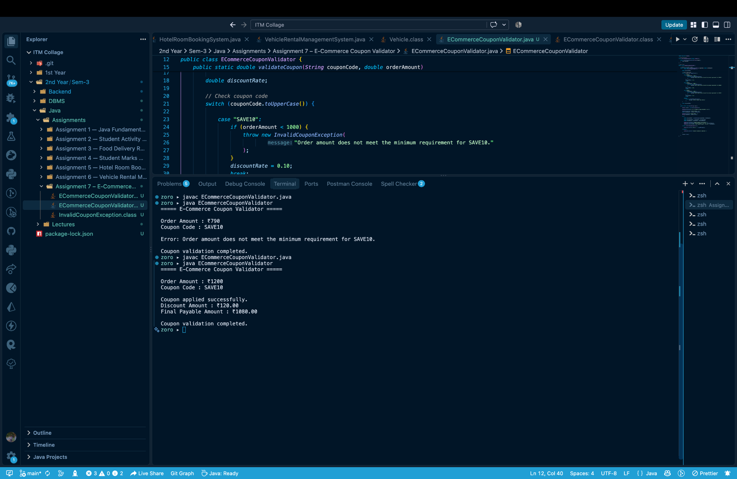
Figure 1: Java program compilation and execution.

8. Output Analysis
For ₹790 with SAVE10, the program correctly reports that the ₹1,000 minimum requirement is not met. For ₹1200 with SAVE10, a 10% discount of ₹120.00 is applied and the final payable amount is ₹1080.00. In both cases, the finally block prints the validation-completed message.

9. Requirement Verification
Requirement | Implementation
Custom exception | InvalidCouponException extends Exception.
Constructor | Accepts a message and calls super(message).
throw | Used for invalid code and insufficient order amount.
throws | Declared by validateCoupon().
try-catch-finally | Implemented in main().
Scanner input | Reads amount and coupon code.
Discount calculation | orderAmount × discountRate.
Final amount | orderAmount − discountAmount.

10. Result
The E-Commerce Coupon Validator was successfully implemented. It validates supported coupons, checks minimum order requirements, calculates discounts correctly, and handles invalid business conditions gracefully using a custom exception.

11. Conclusion
This assignment demonstrates practical Java exception handling through a user-defined exception and the use of throw, throws, try, catch, and finally. The program prevents invalid coupon conditions from terminating the application unexpectedly.

12. Submission Checklist
☑ InvalidCouponException created
☑ throw and throws used correctly
☑ try-catch-finally implemented
☑ Scanner used for input
☑ Discount and final amount calculated
☑ Error messages handled gracefully
☑ Execution screenshot included
☐ Roll number entered before submission

